
Tertiary Infotech Academy Pte Ltd
UEN: 201200696W
LEARNER GUIDE
For
Create Powerpoint Infographics with AI
TGS Ref No: TGS-2026064178
Conducted by
Tertiary Infotech Academy Pte Ltd
UEN: 201200696W
Version 5.2

DOCUMENT VERSION CONTROL RECORD
Version Number | Effective Date of Release | Summary of Included Changes | Author
2.0 | 8 January 2025 | Previous approved Learner Guide release. | Tertiary Infotech Academy Pte Ltd
3.0 | 15 August 2026 | Rebuilt from the approved v10 deck with current Microsoft infographic-maker and Copilot guidance, eight progressive activities, detailed PowerPoint procedures and editable evidence packs. | Tertiary Infotech Academy Pte Ltd
4.0 | 16 August 2026 | Added the AI-first data-to-insight-to-infographic workflow, Microsoft 365 Copilot and Gemini Notebook procedures, PowerPoint conversion and comparison, prompt patterns, mock multi-source data, generated practice assets and verification controls. Migrated the package to current course code TGS-2026064178. | Tertiary Infotech Academy Pte Ltd
5.0 | 5 September 2026 | Retitled the course to Create Powerpoint Infographics with AI and added current Microsoft 365 Copilot infographic creation, structured prompting, source upload, brand and orientation choices, PowerPoint refinement, twelve workplace demonstrations and eight distinct infographic-design activities. | Tertiary Infotech Academy Pte Ltd
5.1 | 5 September 2026 | Aligned the Learner Guide and activities to the three approved topic titles; preserved Copilot prompts, PowerPoint procedures, demonstrations and verification controls. | Tertiary Infotech Academy Pte Ltd
5.2 | 5 September 2026 | Added secure Microsoft 365 Premium training-account access, Copilot infographic launch and sign-out guidance. Credentials remain trainer-issued and are not printed in learner materials. | Tertiary Infotech Academy Pte Ltd

TABLE OF CONTENTS
How to Use This Guide 5
Microsoft 365 Premium Training Account Access 5
Learning Outcomes 5
Infographic Foundations 6
AI-First Data-to-Infographic Workflow 6
PowerPoint Design System 8
Microsoft 365 Copilot Infographic Creation 8
Workplace Infographic Demonstration Gallery 10
Review and Resource Decisions 10
LU1 — AI-Assisted Infographic Planning and Data Insights 11
Activity 1 — Interpret a Statistical KPI Infographic 11
Activity 2 — Design a Comparison Infographic Brief 13
LU2 — Creating PowerPoint Infographics with AI 16
Activity 3 — Create a Timeline Infographic with Microsoft 365 Copilot 16
Activity 4 — Create a Process Infographic with Microsoft 365 Copilot 18
Activity 5 — Create a Comparison Data Story with Copilot and PowerPoint 21
Activity 6 — Create a Hierarchy Infographic with Microsoft 365 Copilot 23
LU3 — Evaluating and Presenting Infographics for Business Impact 25
Activity 7 — Create and Review a Stakeholder Mind Map Infographic 26
Activity 8 — Create a Resource Scorecard Infographic 28
Quick PowerPoint Reference 30
Assessment 31
Assessment Flow 31
Sources and Further Reading 31
Support 31

How to Use This Guide
This guide supports Create Powerpoint Infographics with AI (TGS-2026064178), a one-day WSQ course aligned to Infographics and Data Visualisation (TOU-DAT-4004-1.1-1). Use it with the visual course deck and the individual activity folders. The slides explain concepts and show worked examples; this guide carries the detailed procedures. Each activity folder is self-contained with Microsoft 365 Copilot prompts, mock CSV/Excel data, editable PowerPoint files and verification evidence.
PowerPoint and Copilot interfaces can change. Follow the intent and verify the current control name if your version differs. Use only approved accounts and synthetic or approved data in AI services.
Before class:
- Install or update Microsoft PowerPoint and Excel or confirm Microsoft 365 web access.
- Download the complete activities folder from the LMS or GitHub repository.
- Confirm that every activity folder contains INSTRUCTIONS.md, CHECKLIST.md, PROMPTS.md, CSV, XLSX and PPTX files.
- Keep the original evidence files unchanged; save a named working copy for each activity.

Microsoft 365 Premium Training Account Access
The trainer assigns each learner a Microsoft 365 Premium training account through a private credential card or channel. Usernames and passwords are intentionally not printed in this guide, the slide deck or the public learner repository.
- Obtain your assigned account from the trainer, then open https://m365.cloud.microsoft/
- Sign in with only the account allocated to you and use approved or synthetic activity data.
- Open Microsoft 365 Copilot, choose Create, select Design an infographic, and enter the prompt from your activity folder.
- Download and verify your infographic or PowerPoint working file using the activity naming convention.
- Never change the shared account password, recovery email, security information or multi-factor authentication settings; never share the credentials.
- When finished, sign out of Microsoft 365 and close the browser. If the infographic option is unavailable, inform the trainer and use the supplied editable PowerPoint starter.

Learning Outcomes
- LO1: Draw insights from infographics to make data-driven decisions.
- LO2: Leverage PowerPoint infographics for articulating data insights to stakeholders.
- LO3: Assess the effectiveness of PowerPoint infographics based on allocated resources in accordance with business goals.

Infographic Foundations
An infographic combines concise text, data and visual structure to help an audience understand important information and relationships. A useful infographic is not merely attractive; it answers a question and supports an appropriate decision or action.
Audience question | Useful infographic form | Typical evidence
What changed over time? | Chronology or timeline | Dates, milestones, trend values
How does it work? | Instructional process, cycle or roadmap | Stages, sequence, inputs and outputs
Which option differs? | Comparison or statistical infographic | Comparable metrics and consistent units
How are parts organised? | Hierarchy, tree or mind map | Levels, categories and relationships
What numbers matter? | Statistical dashboard or big-number story | Definitions, denominators, timeframe and source
Insight extraction
- What it shows — State visible values, differences, trends and exceptions.
- What it may mean — Offer a plausible interpretation without implying unsupported causation.
- Why it matters — Connect the pattern to the audience's business question.
- What to do — Recommend a proportionate next step and name uncertainty or evidence gaps.

AI-First Data-to-Infographic Workflow
The default modern workflow is not to construct a full infographic manually from a blank slide. Use approved AI tools to accelerate source organisation, data cleanup, analysis, insight extraction and first-draft visual generation. Use Excel and the original sources to verify evidence, then use PowerPoint as the editable refinement, presentation and release layer.
Collect — Approved files, URLs, transcripts and datasets; record origin and access date.
Clean — Remove duplicates, standardise units and labels, identify missing values and retain the raw source.
Analyse — Ask AI for patterns, exceptions and comparisons, then reproduce critical calculations in Excel.
Extract — Write show–mean–matter–act insights with citations, caveats and forbidden claims.
Generate — In Microsoft 365 Copilot, choose Create > Design an infographic, describe the output, optionally add approved content, choose brand and orientation, then generate.
PowerPoint — Download or rebuild in PPTX; restore editability, charts, source labels, brand and accessibility.
Verify — Compare every claim to source, record prompts and human changes, approve and export.
Data and insight verification gate
- Keep the untouched raw source and create a source register before cleanup.
- Require AI to list proposed transformations, missing data, conflicting definitions and assumptions.
- Reproduce decision-critical totals, percentages, differences and trends with Excel formulas.
- Separate observation from interpretation; add caveats, confidence and forbidden claims.
- Treat AI as an assistant, not as the source of truth or final owner.
Copy-ready prompt patterns
Analyse the evidence — Using only the attached approved source, identify the three strongest patterns, the denominator for each metric, one limitation and one proportionate business action. Cite the source field or row for every number. Do not invent missing values or imply causation.
Create the infographic — Create a one-page [TYPE] infographic about [TOPIC]. Sections: 1. [SECTION ONE] 2. [SECTION TWO] 3. [SECTION THREE] 4. [SECTION FOUR] 5. [SECTION FIVE]. Audience: [AUDIENCE]. Decision: [DECISION]. Style: professional, high contrast, concise, accessible and aligned to [BRAND]. Use only the approved attached content. Include source and period. Do not invent data.
Refine in PowerPoint — Turn the selected infographic direction into one editable PowerPoint slide. Keep the action title, labels, numbers, chart or process, source footer and accessibility notes editable. Remove decoration that does not support the message. Apply the approved brand colours and preserve one clear reading path.
Quality review — Review this infographic against message clarity, data accuracy, visual hierarchy, audience fit, accessibility, editability and business goal. List each issue with evidence, its impact, the proposed change and a pass/fail acceptance check. Do not rewrite verified facts.

PowerPoint Design System
Design decision | Use in PowerPoint | Quality check
Canvas | Design > Slide Size > Custom Slide Size | Output orientation and channel are defined
Grid | View > Ruler, Gridlines and Guides | Margins and spacing are consistent
Shapes | Insert > Shapes; merge, align, distribute and group | One visual grammar supports the relationship
Icons and images | Insert > Icons or Stock Images | Relevant, consistent, labelled and permitted
Typography | One heading family, one body family, few sizes | Readable hierarchy; no cramped paragraphs
Colour | Restrained palette with one purposeful accent | Meaning does not rely on colour alone
SmartArt | Process, cycle, list, hierarchy or timeline | Structure fits; editability is retained
Charts | Native PowerPoint chart or embedded/linked Excel | Action title, direct labels, units and source are visible

Microsoft 365 Copilot Infographic Creation
The Microsoft 365 Copilot app can create an infographic from a detailed description and, where available, approved uploaded content. Learners can choose Brand and color, select Portrait or Wide, generate alternatives, then copy, edit or download the result. Copilot in PowerPoint can add, restructure and refine slide content. Availability depends on licence, region, administrator settings and current product rollout.
Current Microsoft workflow
Describe — State type, topic, sections, audience, decision, style and source constraints.
Add content — Upload only approved content when the feature and policy allow it.
Brand and color — Use an approved brand kit or a controlled palette.
Orientation — Choose Portrait for one-page reading or Wide for a presentation slide.
Create — Generate options, inspect the result and keep the strongest direction.
Edit or download — Correct facts, refine hierarchy and bring the accountable master into PowerPoint.
Structured sample prompt
The prompt below follows the user-supplied example and adds audience, decision, accessibility and source controls.
Create a one-page process infographic about cybersecurity awareness.
Sections:
1. Common threats
2. Phishing examples
3. Safe password practices
4. Multi-factor authentication
5. Reporting suspicious activity
Audience: office employees
Decision: recognise, avoid and report suspicious activity
Style: professional, high contrast and accessible
Source rule: use only the attached approved policy; do not invent facts
Prompt anatomy
Prompt field | What to specify | Verification question
Type and topic | Timeline, process, comparison, statistical, hierarchy, mind map or scorecard | Does the form match the relationship?
Sections | Ordered content blocks with direct labels | Does each section earn space?
Audience and decision | Who will use the visual and what they must decide or do | Can the audience state the action?
Style and format | Professional, brand, contrast, Portrait or Wide | Does the channel fit the output?
Source rule | Approved attachment, period, scope and forbidden claims | Can every claim be traced?
Human review gate
- Truth — verify every number, label, source and implied relationship.
- Privacy — use only approved data and services; do not upload personal or restricted information.
- Rights — confirm template, image, icon, font and generated-asset permissions.
- Accessibility — check reading order, contrast, direct labels, text size and alt text.
- Brand — apply the approved master, palette, logo, tone and ownership.
- Editability — rebuild decision-critical evidence as native objects and test export.

Workplace Infographic Demonstration Gallery
The course deck contains twelve editable demonstration infographics. Each uses realistic workplace decisions with synthetic training data so learners can study the visual mechanism without mistaking the example for operational evidence.
Infographic type | Workplace use case | Decision or action
Statistical dashboard | Retail customer experience | Test a first-purchase onboarding message before changing the full service model.
Comparison | Category promotion decision | Use Ready Meals as the next campaign test while monitoring returns.
Timeline | Employee onboarding | Move account provisioning to the pre-boarding week.
Process | Cybersecurity awareness | Make the reporting step visible beside every email client shortcut.
Cycle | Service improvement | Close each monthly cycle with one owned experiment.
Funnel | SaaS adoption | Reduce the steps between sign-up and first successful task.
Hierarchy | Strategy communication | Show ownership and review cadence below every business goal.
Mind map | Stakeholder communication | Keep one core claim, then vary depth by audience.
Geographic | Store operations | Pilot queue redesign in the West region before network-wide rollout.
Before and after | Operations redesign | Standardise the five-step flow and audit exceptions for four weeks.
Resource scorecard | LO3 tool investment | Fund the workflow with quarterly accuracy and accessibility reviews.
Decision matrix | Channel selection | Use Wide for the briefing and export a separate Portrait handout.

Review and Resource Decisions
Review an infographic against observed audience outcomes and the six dimensions below. Feedback should describe what is visible, ask about the objective, connect the issue to a principle and propose one testable improvement.
Dimension | Review question
Message clarity | Can the audience state the intended takeaway and action?
Data integrity | Are values, units, context, source and uncertainty accurate?
Visual hierarchy | Is the reading order obvious and purposeful?
Accessibility | Are contrast, labels, text size, alt text and non-colour cues adequate?
Engagement | Does the visual earn attention without chart junk or decoration?
Business and resource fit | Does it support the decision, channel, budget, workflow and governance needs?

LU1 — AI-Assisted Infographic Planning and Data Insights
Purpose · Types · Audience · Metrics · Planning · Insight extraction
Key concepts
- An infographic combines concise text, data, shapes, colour, charts and icons to reveal information and relationships.
- Chronology, timeline, process, comparison, statistical, mind map, numerical and hierarchical formats answer different questions.
- A Copilot-first workflow gathers approved sources, cleans and analyses data, extracts candidate insights, then routes verified evidence into visual generation.
- Insight extraction distinguishes what the chart shows, what it means, why it matters and what action is justified.

Activity 1 — Interpret a Statistical KPI Infographic
Objective: Interpret a statistical kpi infographic, verify its denominators and convert visible patterns into defensible business decisions.
Output: A verified statistical KPI infographic, prompt/source log, annotated insight slide and one-sentence recommendation (35 minutes).
Scenario
Northstar Retail's marketing lead has a one-page customer survey infographic built from 420 synthetic Q2 responses. Leadership wants to know which customer experience deserves further investigation.
Use Microsoft 365 Copilot with the supplied approved data summary to propose candidate insights. Verify every number in Excel before recommending one next step.
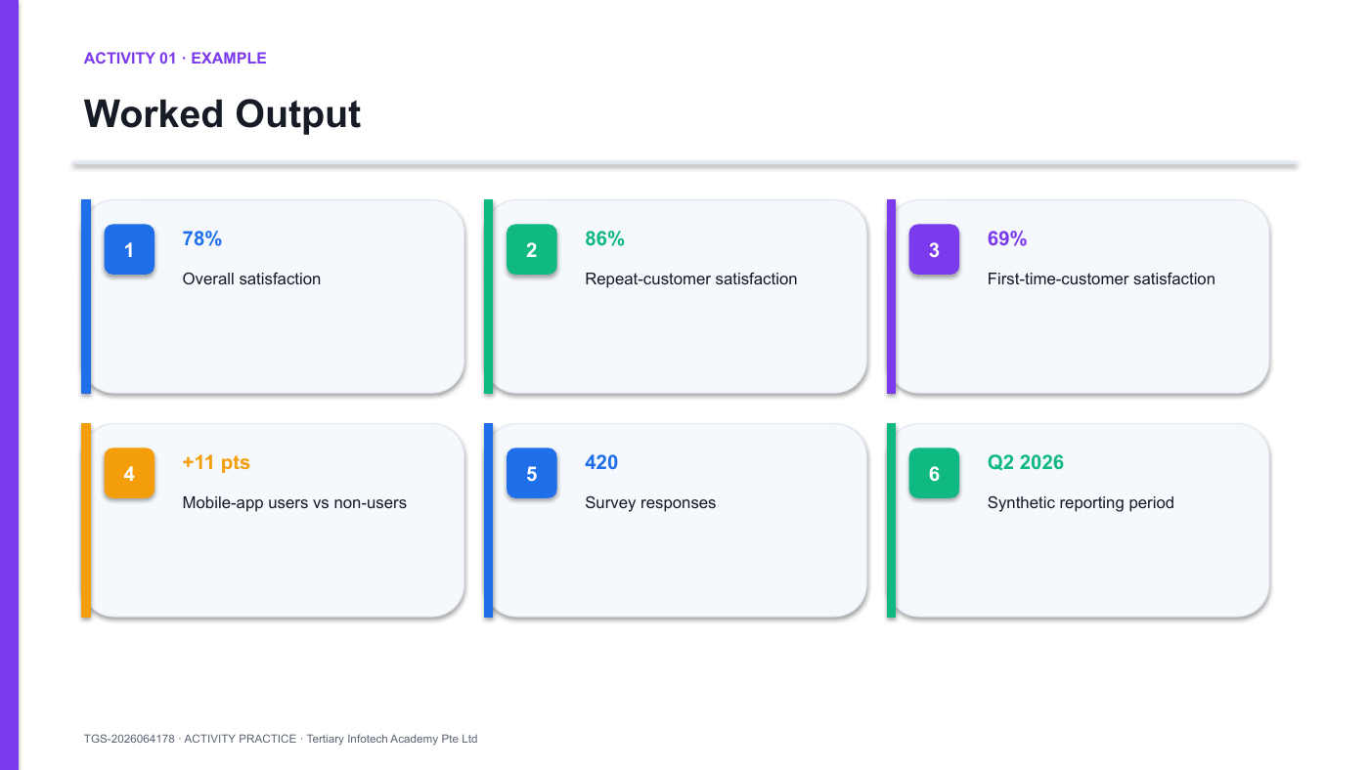
Activity 1 workflow/output preview — use the editable PPTX in the activity folder.
Detailed step-by-step procedure
- Register the sources — Open the A01 XLSX, CSV and Source Notes sheet. In the AI Prompt Lab record each source, its period, data status, owner and permitted use before uploading anything.
- Preserve the raw data — Save a named working copy. Do not modify or replace the raw CSV; perform cleanup on a separate worksheet or in an approved AI session.
- Run the data-cleaning prompt — Copy the Analyse the evidence prompt from PROMPTS.md into Microsoft 365 Copilot. Ask it to flag duplicates, missing values, inconsistent labels, units and periods and to describe every proposed transformation. Require no invented values.
- Verify the cleanup — Compare the AI response with the raw CSV. Apply only justified changes in the workbook, retain a before/after note and confirm the response count remains 420.
- Ask for candidate insights — Request the largest, smallest, gap, exception and competing explanation. Require each candidate insight to cite the exact rows or source fields used.
- Reproduce the calculations — Use the Analysis sheet and Excel formulas to reproduce every critical difference or percentage. Reject any AI claim that cannot be reproduced.
- Write the insight chain — Complete What it shows; What it may mean; Why it matters; What action is justified. Add one caveat or confidence note.
- Build the PowerPoint evidence — Open the A01 start PPTX, save a working copy, add one editable annotation and show Synthetic Northstar Retail data, Q2 2026, n=420 in the source footer.
- Complete the prompt log — Record the AI tool, full prompt, approved inputs, output reviewed, rejected claims, human changes, reviewer and final owner.
Test it
Change one value in a named workbook copy. Recalculate the insight and confirm the PowerPoint claim, source note and caveat still agree.
Suggested timing
Minutes | Phase
5 min | Review the question and evidence definitions
8 min | Read values and denominators
12 min | Build the insight chain and annotation
7 min | Peer challenge and revision
3 min | Save and submit
Acceptance checklist
- Observation uses visible values and correct units
- Interpretation is labelled as interpretation, not fact
- Source, timeframe and sample size are visible
- Action is proportionate to the evidence
- Editable PPTX opens without repair
Discussion and debrief
- What is the strongest visible pattern?
- Which denominator or segment could change the interpretation?
- What can be said confidently, and what cannot?
- What business action is proportionate to the evidence?
Debrief standard: The final insight clearly separates what the data shows, what it may mean, why it matters and what should happen next.

Activity 2 — Design a Comparison Infographic Brief
Objective: Turn verified insights into a structured microsoft 365 copilot brief for a comparison infographic that controls audience, message, evidence and output.
Output: A structured Copilot prompt, two comparison-infographic directions and one approved PowerPoint wireframe (35 minutes).
Scenario
Northstar plans a sustainable-delivery campaign. The communication manager needs a portrait infographic showing the customer journey from order to low-emission delivery.
Use the supplied structured prompt workbook to ask Microsoft 365 Copilot for two comparison-infographic directions. Select one by evidence fit, then preserve it as the control brief for PowerPoint.
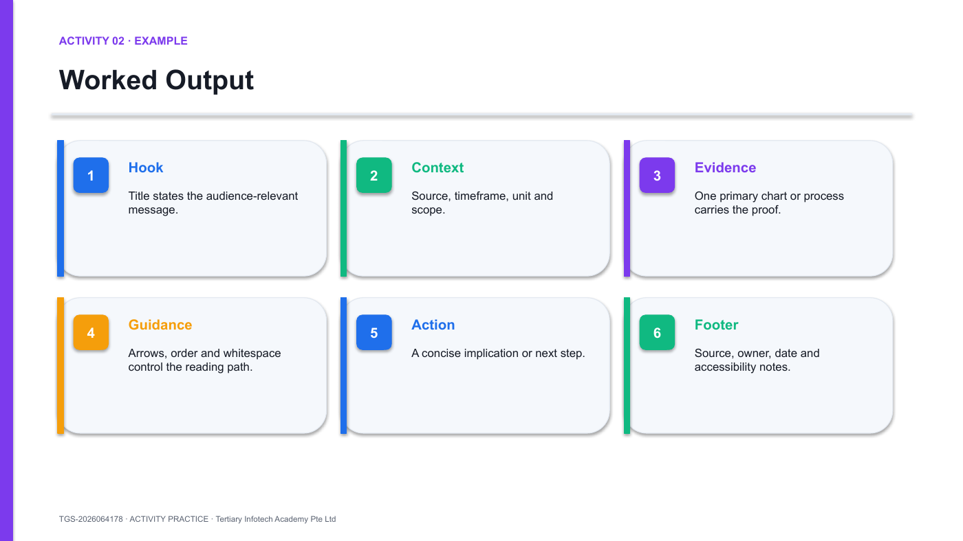
Activity 2 workflow/output preview — use the editable PPTX in the activity folder.
Detailed step-by-step procedure
- Open the brief and prompt pack — Open the A02 workbook, PROMPTS.md and start PPTX. Save named working copies and select only the verified A01 insight chain as input.
- Define the control brief — Complete Audience, Business question, Desired action, Success evidence, approved claims, forbidden claims, output channel and owner.
- Choose the infographic form — Select timeline, process, comparison, statistical, hierarchy or hybrid. Explain why it reveals the relationship better than two alternatives.
- Write the structured prompt — Use the prompt anatomy in the workbook: role, audience, objective, approved evidence, hierarchy, format, brand, accessibility, constraints and output.
- Request two directions — Ask Microsoft 365 Copilot for two low-fidelity comparison-infographic directions. Require labelled content zones, source space and no invented data or imagery.
- Score the directions — Compare both options for question fit, hierarchy, evidence space, reading order, accessibility and ease of PowerPoint refinement.
- Build the approved wireframe — In PowerPoint set a portrait canvas, turn on guides and recreate only the selected direction with editable grey placeholders.
- Test the reading path — Zoom to 25 percent. Ask a peer to point to first, second and last. Move or simplify blocks until the intended order is consistent.
- Record the decision — Capture the chosen direction, rejected option, prompt, removed content, intended channel, accessibility risks, reviewer and owner.
Test it
Show the wireframe at 25% zoom for five seconds. Ask a peer to identify the first, second and final reading points without coaching.
Suggested timing
Minutes | Phase
5 min | Complete the brief
5 min | Choose and justify the form
15 min | Build the portrait wireframe
7 min | Test the reading path
3 min | Save and submit
Acceptance checklist
- Audience question and action are explicit
- Infographic form matches the relationship
- Wireframe works without colour
- Reading order is obvious at thumbnail size
- Space exists for source and accessibility notes
Discussion and debrief
- What is the single audience question?
- Which infographic type best reveals the relationship?
- What content should be removed?
- Where should the reader's eye land first, second and last?
Debrief standard: The wireframe communicates objective, hierarchy, evidence, flow, action and source space before visual styling begins.

LU2 — Creating PowerPoint Infographics with AI
Slide size · Grid · Shapes · Icons · Type · Colour · SmartArt · Charts · AI
Key concepts
- Visual hierarchy uses scale, position, contrast, spacing and alignment to guide the reader through one intended path.
- PowerPoint is the editable refinement layer for AI-generated structure, imagery, text, shapes, SmartArt, native charts and Excel-linked data.
- The Microsoft 365 Copilot app can generate an infographic from a detailed prompt and, where available, approved uploaded content for grounding.
- Every AI-assisted output needs source verification, privacy review, brand control, accessibility checks and editable hand-off.

Activity 3 — Create a Timeline Infographic with Microsoft 365 Copilot
Objective: Create a timeline infographic in the microsoft 365 copilot app, then preserve hierarchy, editability, brand and evidence in powerpoint.
Output: An editable five-milestone timeline infographic in PPTX, PDF and JPG (40 minutes).
Scenario
Northstar HR needs a five-milestone onboarding timeline for managers: account request, manager plan, Day 1 orientation, Day 7 skills check and Day 30 outcome review.
Use Microsoft 365 Copilot Create > Design an infographic with the supplied structured prompt and approved brief. Refine the selected Wide timeline in PowerPoint; do not let generated decoration replace dated evidence.
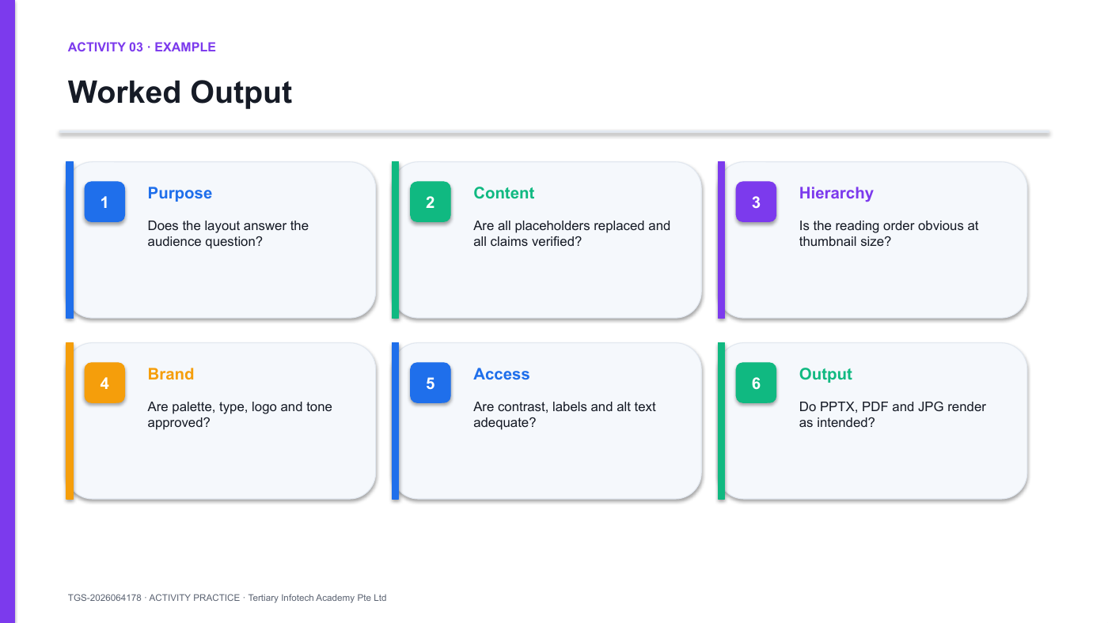
Activity 3 workflow/output preview — use the editable PPTX in the activity folder.
Detailed step-by-step procedure
- Open Microsoft 365 Copilot — Open the Microsoft 365 Copilot app and sign in only with an approved account. Choose Create > Design an infographic. If the feature is unavailable, use the supplied editable start deck and record the fallback.
- Write the timeline prompt — Copy the structured prompt from PROMPTS.md. Specify five onboarding milestones, the manager audience, the pre-boarding decision, professional style, Wide format and the approved source rule.
- Add approved content — Select +Add content where available and choose only the supplied onboarding brief or workbook. Do not upload personal employee records or restricted files.
- Choose brand and format — Select Brand and color where available, then choose Wide format for a presentation slide. Keep the approved blue, teal, violet and amber system.
- Generate and select — Select Create, inspect the alternatives and choose the direction with the clearest chronological order. Reject any option with invented dates, labels or outcomes.
- Apply the approved style — Use Design > Variants > Colors and Fonts or apply the supplied palette manually. Keep one heading font, one body font and consistent stage colours.
- Check alignment — Select comparable stage objects, then choose Shape Format > Align > Align Middle and Distribute Vertically. Group each stage after alignment.
- Add accessibility data — Right-click meaningful images and choose View Alt Text. Write purpose-focused alt text; mark decorative objects as decorative where supported.
- Export and inspect — Use File > Export > Create PDF/XPS for PDF and File > Save As > PNG for an image. Compare the outputs with the editable master for clipping and font changes.
Test it
Move one stage group and export a fresh PDF. Confirm connectors, labels, hierarchy, source and alt-text decisions remain correct.
Suggested timing
Minutes | Phase
5 min | Template selection and working copy
10 min | Placeholder audit and content replacement
15 min | Brand, hierarchy and alignment
7 min | Accessibility and export
3 min | Save and submit
Acceptance checklist
- Template relationship matches the brief
- No placeholder text remains
- Brand and visual hierarchy are consistent
- Source and alt text are present
- PPTX, PDF and JPG render correctly
Discussion and debrief
- Why does this template fit the question?
- Which inherited element should be removed first?
- What must remain editable?
- Which export format fits each channel?
Debrief standard: The final template-based infographic is message-led, branded, accessible, source-labelled and fully editable.

Activity 4 — Create a Process Infographic with Microsoft 365 Copilot
Objective: Use microsoft 365 copilot to generate a five-stage process infographic, then rebuild decision-critical labels, shapes, connectors and smartart as editable powerpoint objects.
Output: A Copilot prompt log, editable five-stage process infographic and reusable PowerPoint component slide (35 minutes).
Scenario
Northstar needs an editable five-stage sustainable-delivery process infographic for store managers. Use the supplied structured Microsoft 365 Copilot prompt and approved synthetic stage data.
Treat the Copilot output as a design direction. Build all stage names, values, connectors, source labels and decision meaning as editable PowerPoint objects.
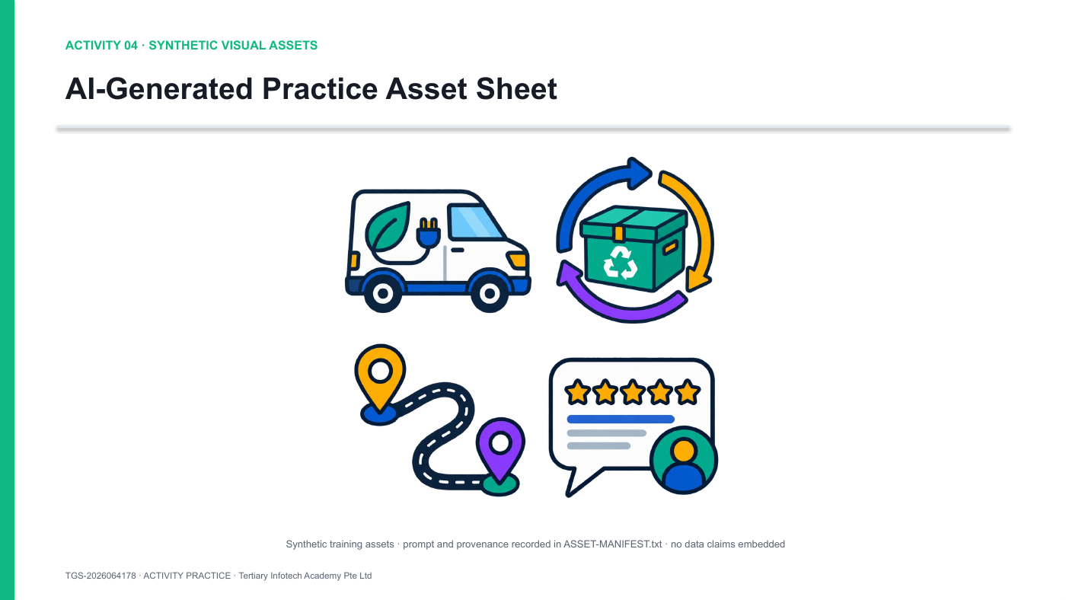
Activity 4 workflow/output preview — use the editable PPTX in the activity folder.
Detailed step-by-step procedure
- Review the source and prompt — Open the A04 workbook and PROMPTS.md. Confirm the five approved stages, audience, decision, source note and forbidden claims before using Copilot.
- Generate the process direction — In Microsoft 365 Copilot choose Create > Design an infographic. Submit the structured process prompt, add only the approved source content, choose Wide and apply the approved brand colours.
- Inspect before use — Reject any result with the wrong sequence, invented facts, embedded unreadable text, ambiguous symbols or inconsistent visual grammar. Record the accepted and rejected options.
- Preserve the original — Copy or download the selected Copilot output as evidence. Work on a named PowerPoint copy so the generated direction remains available for comparison.
- Open the PowerPoint start file — Save a named working copy, set guides and margins, and insert only the approved assets.
- Build editable information — Create the five stage containers, titles, metrics, connectors, source notes and decision labels as native PowerPoint objects. Do not bake claims into the image.
- Align and distribute — Use Shape Format > Align and Distribute. Group each stage logically while keeping text and data editable.
- Add accessibility — Write purpose-focused alt text for meaningful assets, mark decorative assets where appropriate and preserve direct text labels.
- Complete provenance — Record Microsoft 365 Copilot, exact prompt, date, source status, intended use, rejected output, human changes, reviewer and owner in the workbook.
Test it
Replace one Copilot-generated process direction. Confirm all facts, labels, connectors and sources remain separate, native and editable in PowerPoint.
Suggested timing
Minutes | Phase
5 min | Set grid and build first component
15 min | Duplicate, align and connect
8 min | Insert and format icons
5 min | Compare SmartArt
2 min | Save and submit
Acceptance checklist
- Stages use equal size and spacing
- Connectors remain attached when objects move
- Icons use one family and have direct labels
- The reading path is obvious
- All objects remain editable and grouped logically
Discussion and debrief
- Which visual property signals sequence?
- Where is direct labelling still required?
- Would SmartArt clarify or constrain this design?
- How will the system remain reusable?
Debrief standard: The process uses a consistent component system, real connectors, direct labels, purposeful whitespace and editable PowerPoint objects.

Activity 5 — Create a Comparison Data Story with Copilot and PowerPoint
Objective: Use microsoft 365 copilot to analyse approved mock excel data, verify calculations, then create a comparison infographic with a native editable chart in powerpoint.
Output: A Copilot analysis log, verified formula workbook, comparison infographic and annotated decision slide (45 minutes).
Scenario
Northstar's marketing team must choose one product family for the next promotion. The supplied workbook contains monthly revenue, units, margin and returns for four categories.
Prompt an approved AI assistant to analyse the workbook and propose candidate insights. Reproduce the selected calculations in Excel, then create an editable PowerPoint chart with an explicit decision implication.
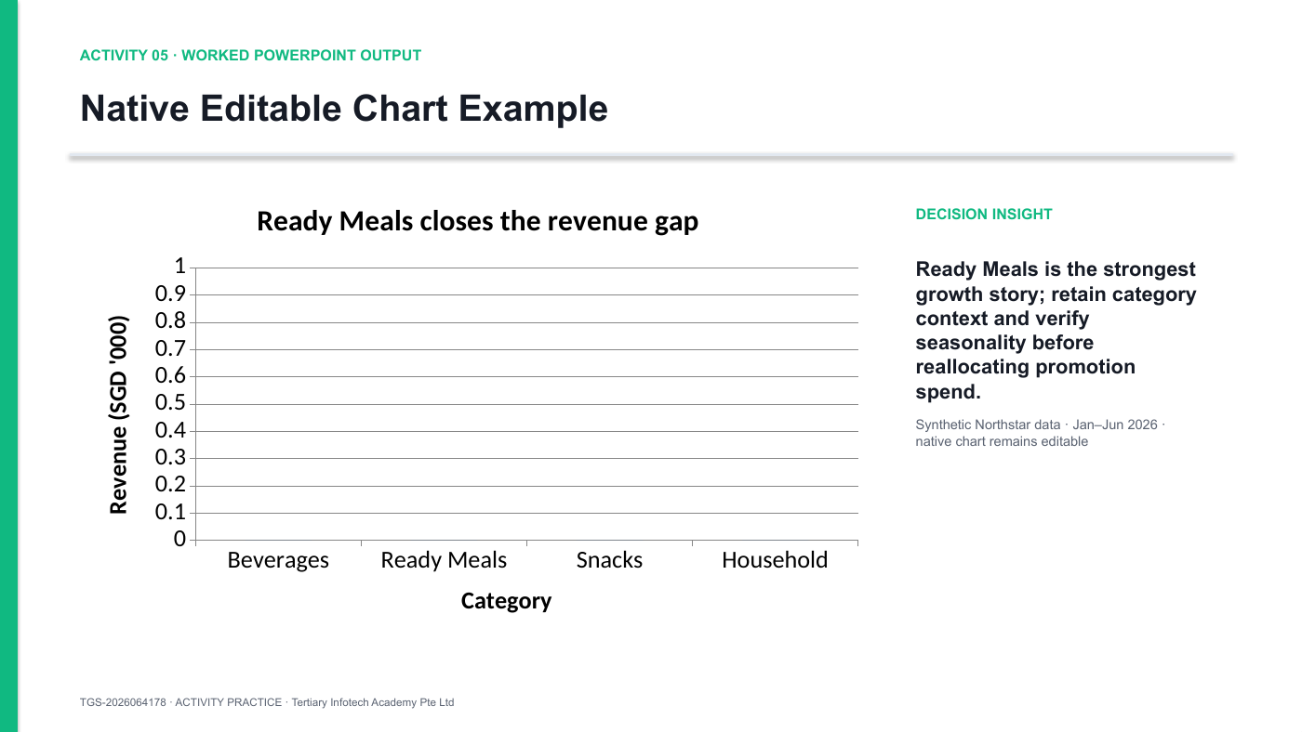
Activity 5 workflow/output preview — use the editable PPTX in the activity folder.
Detailed step-by-step procedure
- Open and validate the workbook — Open the A05 XLSX. Review Data, Analysis, Source Notes and AI Prompt Lab. Change one input value and confirm formulas update without errors.
- Run the analysis prompt — Ask Microsoft 365 Copilot to flag data-quality issues, compare revenue, growth, margin and returns, calculate candidate metrics and cite the relevant rows. Require no invented values.
- Verify every calculation — Reproduce the selected growth, totals, averages and comparisons with Excel formulas. Record any rejected AI claim and why.
- Define the decision metric — State which product family to promote and the minimum evidence required. Separate observed patterns from hypotheses and caveats.
- Choose the chart — Use a clustered bar for category comparison or a line for change over time. Explain why the chart reveals the relationship better than a pie or 3-D chart.
- Create the Excel chart — Select the prepared Analysis range, choose Insert > Recommended Charts, select the intended chart, and add a precise chart title.
- Paste as a native chart — Copy the chart. In PowerPoint choose Home > Paste > Use Destination Theme & Embed Workbook or Keep Source Formatting & Link Data. Do not paste as a picture.
- Remove chart junk — Use Chart Design > Add Chart Element. Keep only necessary axes, direct labels and a short title. Remove background fills, 3-D effects, unnecessary gridlines and legends.
- Write the action title — Replace the topic title with a sentence that states the supported conclusion, for example Ready Meals combine the fastest Q2 growth with above-floor margin.
- Highlight the decision — Use one accent colour for the selected category. Keep all comparison categories neutral and add one concise annotation.
- Add source and limitation — Show Synthetic Northstar data, Jan-Jun 2026 and one relevant caveat such as promotional seasonality or return-rate uncertainty.
- Test refresh and log — Change one workbook input, refresh the chart and confirm the visual updates. Complete the AI prompt/source log with tool, prompt, output, verification and owner.
Test it
Change one Excel input, refresh the native chart and verify the action title, direct labels, unit and limitation against the updated data.
Suggested timing
Minutes | Phase
8 min | Validate data and define metrics
10 min | Build the Excel chart
15 min | Paste and format the native chart
8 min | Write insight, source and limitation
4 min | Refresh test and submit
Acceptance checklist
- Workbook has zero formula errors
- Chart type matches the relationship
- Action title states a defensible insight
- One accent highlights the decision
- Source, timeframe, unit and limitation are visible
Discussion and debrief
- Which metric answers the actual business question?
- What does the chart show that a table does not?
- Which context or caveat belongs on the slide?
- Which product should be tested and why?
Debrief standard: The chart is native/editable, uses an appropriate form, retains source context and makes a proportionate product-promotion recommendation.

Activity 6 — Create a Hierarchy Infographic with Microsoft 365 Copilot
Objective: Generate a source-grounded business-goal hierarchy in microsoft 365 copilot and refine it as an accountable editable powerpoint master.
Output: Two Copilot hierarchy directions, a reviewed editable PowerPoint hierarchy and a prompt/source log (45 minutes).
Scenario
Northstar wants an executive hierarchy infographic connecting its service-trust goal to a recovery outcome, a four-hour measure, the customer-operations owner and a monthly review.
Use Microsoft 365 Copilot with the approved strategy note to create two hierarchy directions. Verify the relationships, then rebuild the selected direction as an editable PowerPoint hierarchy.
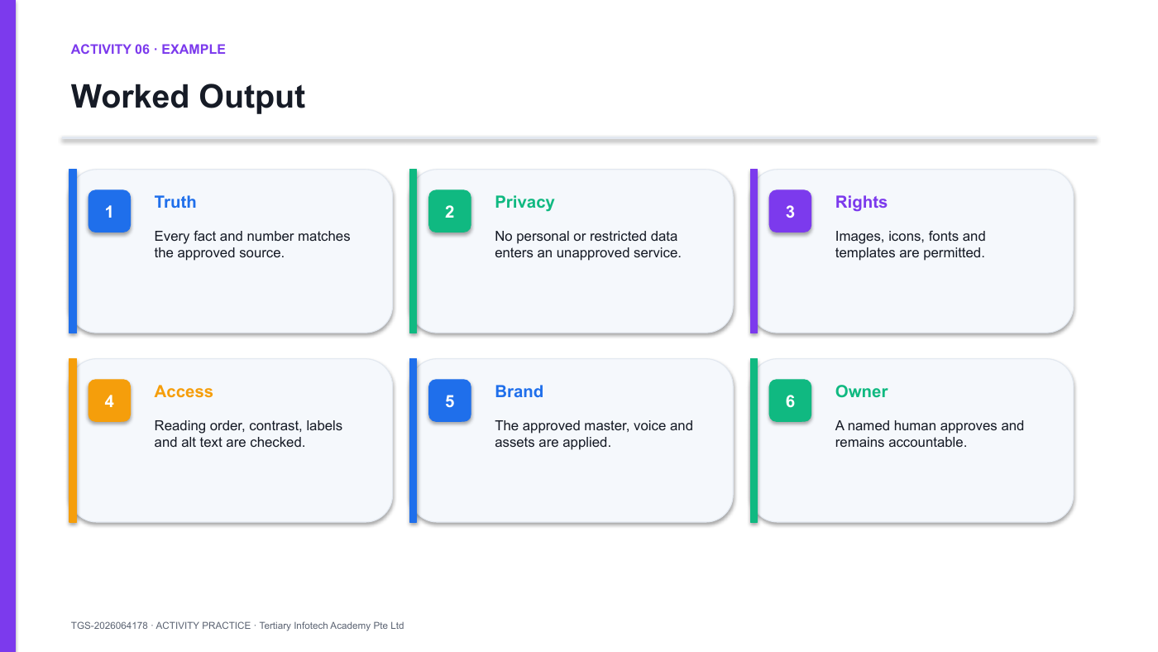
Activity 6 workflow/output preview — use the editable PPTX in the activity folder.
Detailed step-by-step procedure
- Open the hierarchy brief — Open the A06 workbook, PROMPTS.md and source-pack folder. Complete the audience, business goal, outcome, measure, owner, review cadence, approved sources and forbidden claims.
- Run the Copilot route — In the Microsoft 365 Copilot app choose Create > Design an infographic. Add the approved strategy note where available, submit the hierarchy prompt, choose Wide and apply the approved brand colours.
- Generate two directions — Request two hierarchy alternatives: a top-down tree and a cascading goal-to-owner flow. Preserve both outputs unchanged as evidence.
- Score the hierarchy — Use the workbook to score relationship accuracy, source grounding, hierarchy, editability, brand, accessibility and business usefulness.
- Verify every relationship — Compare every goal, outcome, measure, owner and review statement with the approved source pack. Reject any inferred target or ownership statement that is not supported.
- Refine in PowerPoint — Choose the stronger direction. Rebuild decision-critical text, connectors and levels as native objects; apply brand, source footer, alt text and correct reading order.
- Test the chain — Ask a peer to read from goal to review and explain the logic. Revise any ambiguous connector or level, then export PDF and compare it with the editable master.
- Record ownership — Complete the prompt/source log with selected sources, both Copilot outputs, rejected claims, human changes, reviewer and final owner.
Test it
Read the hierarchy from business goal to review cadence. Trace every level to the approved source and document any relationship Copilot inferred incorrectly.
Suggested timing
Minutes | Phase
7 min | Complete the structured prompt
8 min | Generate two hierarchy options
10 min | Score and verify
15 min | Rebuild and check accessibility
5 min | Complete log and submit
Acceptance checklist
- Both hierarchy directions use the same approved brief and source scope
- Goal, outcome, measure, owner and review logic are visible
- Every claim matches the source pack
- Critical evidence is editable in the final PowerPoint
- Prompts, human changes, reviewer and owner are recorded
Discussion and debrief
- What must the prompt include to prevent a generic output?
- Which data cannot be sent to an unapproved service?
- What must be rebuilt as native PowerPoint objects?
- Who signs off the final infographic?
Debrief standard: The final slide records the prompt, sources and human changes; all claims are verified and the decision evidence remains editable.

LU3 — Evaluating and Presenting Infographics for Business Impact
Story · Context · Simplicity · Coaching · Budget · Effectiveness · Improvement
Key concepts
- Effective review separates message clarity, data integrity, visual hierarchy, accessibility, audience fit and business usefulness.
- Coaching uses specific observations, questions and criteria rather than taste-based comments such as 'make it pop'.
- Tool investment is evaluated through capability, licence, learning, production, governance, collaboration and maintenance costs.
- Improvement is evidence-led: gather feedback, prioritise changes, revise the controlled master and retest the intended outcome.

Activity 7 — Create and Review a Stakeholder Mind Map Infographic
Objective: Create a stakeholder mind map, give criteria-based feedback and revise it to improve clarity, story and accessibility.
Output: A stakeholder mind map infographic, completed peer-review log, revised PowerPoint and short reflection (30 minutes).
Scenario
Each learner uses Microsoft 365 Copilot to draft a stakeholder mind map linking executives, managers, analysts, staff and customers to one common decision story.
Present the editable PowerPoint mind map to two peers. Capture two observations, two strengths, two improvements and one agreed revision, then retest the reading path.
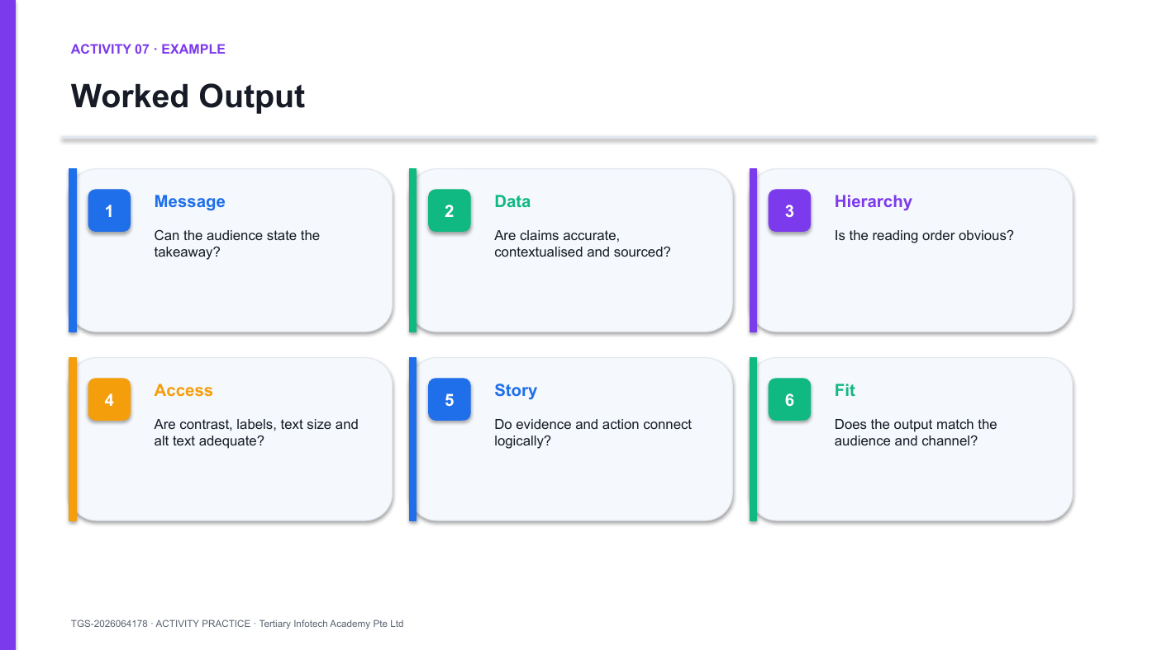
Activity 7 workflow/output preview — use the editable PPTX in the activity folder.
Roles
- Designer — Goal: explain the intended audience and message. Listen without defending every choice; ask for evidence.
- Reviewer — Goal: give criteria-based feedback. Use observations, questions and one prioritised suggestion.
- Audience representative — Goal: test comprehension. State what you understood, what confused you and what action you would take.
Detailed step-by-step procedure
- Generate the mind map — Use Microsoft 365 Copilot to draft a stakeholder mind map linking executives, managers, analysts, staff and customers to one decision story. Preserve the prompt and generated option.
- Create the review slide — Rebuild the selected mind map as an editable PowerPoint slide, with direct labels, purposeful connectors, a source note and one central decision.
- Assign roles — Work in groups of three: Designer, Reviewer and Audience representative. Rotate roles if time permits.
- Run the five-second test — Show the slide for five seconds, then hide it. The audience representative states the message, evidence and intended action they remember.
- Record observations — In A07-Peer-Coaching-and-Story-Review-Data.xlsx capture visible facts only: reading order, text size, labels, contrast, source, chart comprehension and action clarity.
- Ask clarifying questions — The reviewer asks which audience, message, evidence and constraint drove the design. The designer answers without dismissing the observation.
- Apply the six-lens rubric — Score Message, Data, Hierarchy, Accessibility, Story and Channel fit. Add one evidence note for every score.
- Prioritise one change — Choose the issue with the largest audience or decision impact. State the change, owner and acceptance check.
- Revise the master — Update the editable PPTX. Do not flatten the file or create an uncontrolled duplicate.
- Retest and reflect — Repeat the five-second test and write 150-250 words on what improved, what remains and why.
Test it
Generate the stakeholder mind map, then repeat the five-second audience test before and after revision. Record the observed change in recall, reading order or action clarity.
Suggested timing
Minutes | Phase
5 min | Assign roles and run five-second test
10 min | Observe, question and score
8 min | Prioritise and revise
5 min | Retest
2 min | Save reflection
Acceptance checklist
- Feedback contains observations, not taste-only comments
- Every score has evidence
- One high-impact change is prioritised
- Revised PPTX remains editable
- Reflection explains how the change affects audience understanding
Discussion and debrief
- What did the audience understand first?
- Which issue has the greatest decision impact?
- Which feedback is evidence-based rather than taste?
- How will the change be tested?
Debrief standard: The review log contains observed evidence, a principle-based diagnosis, one prioritised change, a named owner and an acceptance check.

Activity 8 — Create a Resource Scorecard Infographic
Objective: Compare infographic-tool investment options and recommend a resource plan using effectiveness and governance criteria.
Output: A weighted resource-scorecard infographic and one-page workflow recommendation (30 minutes).
Scenario
Northstar can fund one standard workflow for 12 staff. Options include PowerPoint templates only, PowerPoint with Microsoft 365 Copilot, a Copilot-first governed workflow, or a mixed approved workflow with PowerPoint as the controlled final-production layer.
Use the supplied budget workbook and effectiveness evidence to recommend a 12-month tool, training and governance plan aligned with business outcomes.
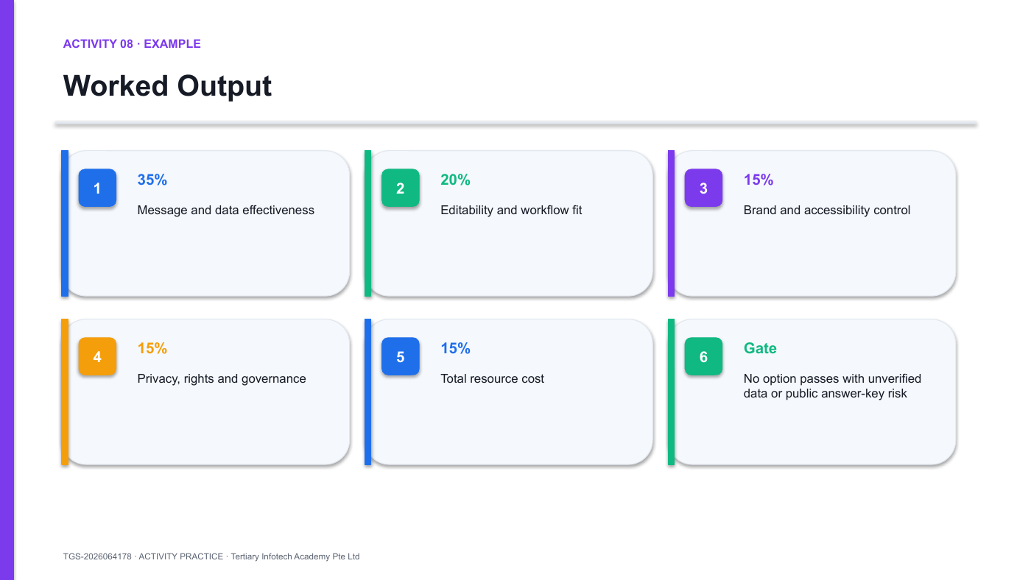
Activity 8 workflow/output preview — use the editable PPTX in the activity folder.
Detailed step-by-step procedure
- Open the options workbook — Open A08-Budget-and-Effectiveness-Decision-Data.xlsx and review Assumptions, Options, Scorecard and Recommendation.
- Confirm the business need — Record the number of users, infographic volume, required channels, approved data classification and business outcome.
- Review total resource cost — Check licence, training, production, review, governance, maintenance and estimated rework costs. Do not compare licence fees alone.
- Set decision weights — Use the supplied weights or adjust them with a written rationale. Keep effectiveness and hard governance gates visible.
- Score each workflow — Score PowerPoint templates, PowerPoint + Copilot, Copilot-first governed workflow and Mixed approved tools + PowerPoint using the same scale and evidence.
- Test hard gates — Mark any option that fails data handling, rights, editability, accessibility or continuity as Not eligible regardless of weighted score.
- Review formulas — Confirm weighted totals and 12-month costs recalculate. Resolve any #REF!, #DIV/0!, #VALUE!, #N/A or #NAME? error before proceeding.
- Write the recommendation — In the Recommendation sheet name the preferred workflow, 12-month budget, training plan, governance controls, owner, success metrics and review date.
- Create the decision slide — Open A08-Budget-and-Effectiveness-Decision-Start.pptx and add a native comparison chart, key trade-offs and one explicit recommendation.
- Challenge the decision — Ask which evidence could reverse the choice. Record the trigger and the date for the formal review.
Test it
Change one decision weight or hard-gate result. Confirm eligibility, weighted score, 12-month cost and recommendation respond as intended.
Suggested timing
Minutes | Phase
5 min | Confirm need and assumptions
10 min | Review cost and score options
7 min | Apply hard gates and validate formulas
6 min | Write recommendation and decision slide
2 min | Challenge and submit
Acceptance checklist
- All options use the same criteria and scale
- Total cost includes hidden resource costs
- Governance gates override weighted score
- Workbook has zero formula errors
- Recommendation names budget, controls, metrics, owner and review date
Discussion and debrief
- Which business outcomes define effectiveness?
- What hidden resource costs could reverse the decision?
- Which risks are hard gates rather than weighted preferences?
- When should the investment be reviewed?
Debrief standard: The recommendation names the preferred workflow, budget, ownership, governance controls, success metrics and review date.

Quick PowerPoint Reference
Task | Ribbon path / method
Change orientation | Design > Slide Size > Custom Slide Size
Show layout aids | View > Ruler, Gridlines, Guides
Align and distribute | Select objects > Shape Format > Align
Manage object order | Home > Select > Selection Pane
Insert icons | Insert > Icons
Insert SmartArt | Insert > SmartArt
Create chart | Insert > Chart, or copy from Excel and choose an embed/link paste option
Add alt text | Right-click object > View Alt Text
Check accessibility | Review > Check Accessibility
Export PDF / image | File > Export or File > Save As

Assessment
- Written Assessment (WA-SAQ) — nine open-ended questions, 30 minutes, open book.
- Practical Performance (PP) — three progressive tasks, 30 minutes, open book.
- Only the course slides, this Learner Guide and approved materials may be used.
- Grading: Competent / Not Yet Competent.
- A minimum of 75% attendance is required. Learners must be assessed as Competent and complete the required digital attendance and TRAQOM steps.

Assessment Flow
- TRAQOM — access the required survey from the LMS.
- Complete Assessment Digital Attendance.
- Sit the Written Assessment (WA-SAQ), then Practical Performance (PP).
- Submit the completed assessment answers on the LMS.
- Sign the Assessment Summary Record.
LMS: https://lms-tms.tertiaryinfotech.com/

Sources and Further Reading
- Microsoft Support: Create an infographic with the Microsoft 365 Copilot app: https://support.microsoft.com/en-us/microsoft-365-copilot/create-an-infographic-with-the-microsoft-365-copilot-app
- User-provided Microsoft 365 Copilot shared prompt example: https://m365.cloud.microsoft/chat/share/eyJzaGFyZUlkIjoiMjlmMmExZWUtMjU2Zi00NTU2LWFlYmUtYjNiNGI0MzNkODE3IiwiY29udmVyc2F0aW9uSWQiOiI2NjU1YjBkMi03MDEzLTQxMzgtYjAyOS1jZGY5NmRkNTY2NmYifQ%3D%3D
- Microsoft Support: Edit with Copilot in PowerPoint: https://support.microsoft.com/en-US/PowerPoint/edit-with-copilot-in-powerpoint
- Microsoft Support: Add a slide from a file with Copilot in PowerPoint: https://support.microsoft.com/en-US/PowerPoint/copilot/add-a-slide-from-a-file-with-copilot-in-powerpoint
- Microsoft Support: Create a new presentation with Copilot in PowerPoint: https://support.microsoft.com/en-gb/copilot-powerpoint
- Microsoft Support: File formats supported by Microsoft 365 Copilot: https://support.microsoft.com/en-US/Microsoft-365-Copilot/file-formats-supported-by-microsoft-365-copilot
- Microsoft Support: Add or remove chart titles: https://support.microsoft.com/office/add-or-remove-titles-in-a-chart-4cf3c009-1482-4908-922a-997c32ea8250
- Microsoft Support: Add alternative text: https://support.microsoft.com/office/add-alternative-text-to-a-shape-picture-chart-smartart-graphic-or-other-object-44989b2a-903c-4d9a-b742-6a75b451c669
- Microsoft Support: Make presentations accessible: https://support.microsoft.com/office/make-your-powerpoint-presentations-accessible-to-people-with-disabilities-6f7772b2-2f33-4bd2-8ca7-dae3b2b3ef25
- Microsoft Support: Change slide size: https://support.microsoft.com/office/change-the-size-of-your-slides-040a811c-be43-40b9-8d04-0de5ed79987e
- Microsoft Support: Align or arrange objects: https://support.microsoft.com/office/align-or-arrange-objects-bfd91078-2078-4b35-8672-f6270690b3b8
- Microsoft Support: Insert icons: https://support.microsoft.com/office/insert-icons-in-microsoft-365-e2459f17-3996-4795-996e-b9a13486fa79
- Microsoft Support: Use charts and graphs: https://support.microsoft.com/office/use-charts-and-graphs-in-your-presentation-c74616f1-a5b2-4a37-8695-fbcc043bf526
- Microsoft Support: SmartArt graphics: https://support.microsoft.com/office/learn-more-about-smartart-graphics-6ea4fdb0-aa40-4fa9-9348-662d8af6ca2c
- W3C: Understanding Success Criterion 1.4.3 Contrast: https://www.w3.org/WAI/WCAG22/Understanding/contrast-minimum.html
- Datawrapper Academy: What to consider when creating charts: https://academy.datawrapper.de/article/127-what-to-consider-when-creating-charts

Support
- Email: enquiry@tertiaryinfotech.com
- Tel: +65 6100 0613
- Website: www.tertiarycourses.com.sg
- LMS: https://lms-tms.tertiaryinfotech.com/

